Character Data Types
# Source: AI Source: Provided by: [Data Path: Persons Table -> ID Column: 1, Name_En Column: Motasem Essam] -> From: [Chatgpt (GPT‑5 Mini)] on [12/10/2025]
A character (char) is a data type used to store a single character such as a letter, number, or symbol.
A char stores only one character at a time and is usually enclosed in single quotes ' ' in many programming languages.

Examples of Character Values
# Source: AI Source: Provided by: [Data Path: Persons Table -> ID Column: 1, Name_En Column: Motasem Essam] -> From: [Chatgpt (GPT‑5 Mini)] on [12/10/2025]
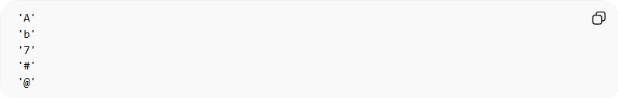
'A'
'b'
'7'
'#'
'@'
Each example represents one single character.

Example in Programming

C / C++ / Java
# Source: AI Source: Provided by: [Data Path: Persons Table -> ID Column: 1, Name_En Column: Motasem Essam] -> From: [Chatgpt (GPT‑5 Mini)] on [12/10/2025]
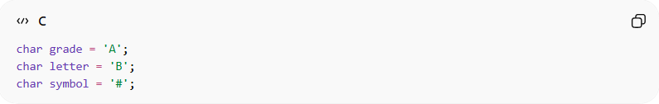
char grade = 'A';
char letter = 'B';
char symbol = '#';

Python
# Source: AI Source: Provided by: [Data Path: Persons Table -> ID Column: 1, Name_En Column: Motasem Essam] -> From: [Chatgpt (GPT‑5 Mini)] on [12/10/2025]
(Python does not have a separate char type; characters are stored as strings of length 1.)
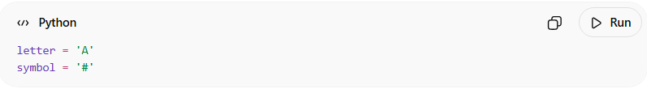
letter = 'A'
symbol = '#'

Key Characteristics
# Source: AI Source: Provided by: [Data Path: Persons Table -> ID Column: 1, Name_En Column: Motasem Essam] -> From: [Chatgpt (GPT‑5 Mini)] on [12/10/2025]
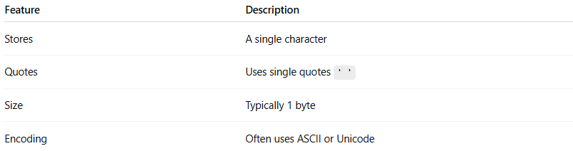
Feature | Description
Stores | A single character
Quotes | Uses single quotes ' '
Size | Typically 1 byte
Encoding | Often uses ASCII or Unicode

ASCII Representation
# Source: AI Source: Provided by: [Data Path: Persons Table -> ID Column: 1, Name_En Column: Motasem Essam] -> From: [Chatgpt (GPT‑5 Mini)] on [12/10/2025]
Characters are internally stored as numeric codes using systems like ASCII.
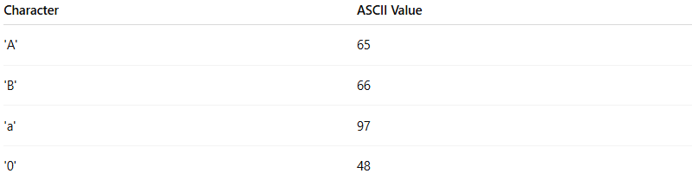
Character | ASCII Value
'A' | 65
'B' | 66
'a' | 97
'0' | 48
Example:
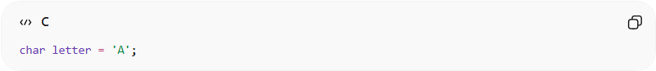
char letter = 'A';
The computer actually stores 65 internally.

Example Use Case
# Source: AI Source: Provided by: [Data Path: Persons Table -> ID Column: 1, Name_En Column: Motasem Essam] -> From: [Chatgpt (GPT‑5 Mini)] on [12/10/2025]
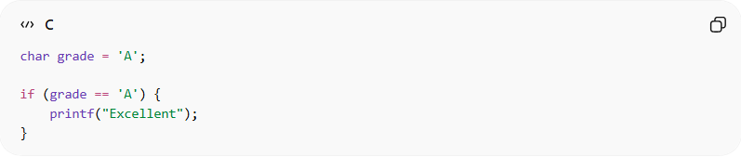
char grade = 'A';

if (grade == 'A') {
printf("Excellent");
}

Difference Between char and string
# Source: AI Source: Provided by: [Data Path: Persons Table -> ID Column: 1, Name_En Column: Motasem Essam] -> From: [Chatgpt (GPT‑5 Mini)] on [12/10/2025]
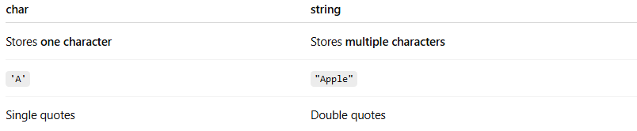
char | string
Stores one character | Stores multiple characters
'A' | "Apple"
Single quotes | Double quotes

